**Comparison of plots**

**.bmp plot**

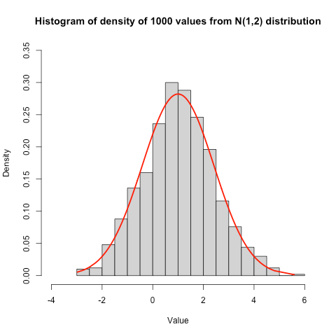

**.jpeg plot**

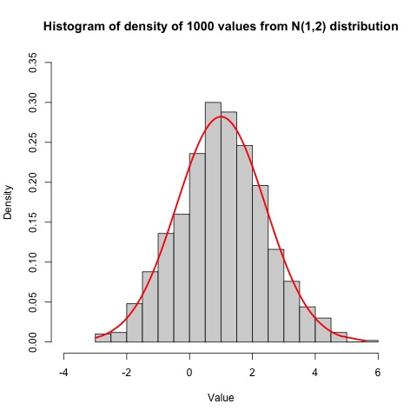

**.png plot**



**.tiff plot**

It seems that the